***FaceHack: Predicting BMI and Gender***

- Thribhuvan S, EC21B1093

- Ambati Lokesh, EC21B1104

- Amar Rohith, EC21B1106

1. *Introduction*

The objective of this project is to leverage a dataset of frontal and side-view mugshots to be able to predict a person’s BMI and gender.

1. *Dataset*

The dataset used in this project consists of public data related to prisoners from Illinois. It consists of .csv files containing features such as prisoner id, name, height, weight, hair color, gender, race, eye color, offense and so on. It also has our required image folders consisting of frontal and side-view mugshots of prisoners, with the image name being an id in the csv file, denoting data of that prisoner.

1. *Methodology*

The aim is to build a CNN-based Deep Learning Model to Predict the BMI and Gender based off the mugshots. The input comes from the image folders containing frontal and side-view mugshots, whereas the output, i.e., BMI and Gender come from the csv files. The BMI is calculated using the formula:

BMI = $$\frac{Weight\left(kg\right)}{Height\left(m\right)2}$$

Since BMI directly depends on height and weight, we will be using them as neither input nor output features. We will be attempting to predict just the BMI, since predicting the height and weight may not be accurate since we are only dealing with close-up pictures of a person’s face.

3. 1. Data Preprocessing:

The pre-processing steps used are as follows:

* Removing records with null or invalid values, as well as corrupted .jpg images, in the side-view images folder.
* Converting certain features to desired data types, such as date-time and numeric types.
* Removing outliers that are more than 3 standard deviations away.
* Converting height and weight to meters and kilograms respectively and adding the BMI feature by applying the formula.

3. 2. Data Visualization:

Dataset has been visualized using some plots. One such plot highlighting the offenses done by inmates is shown below:

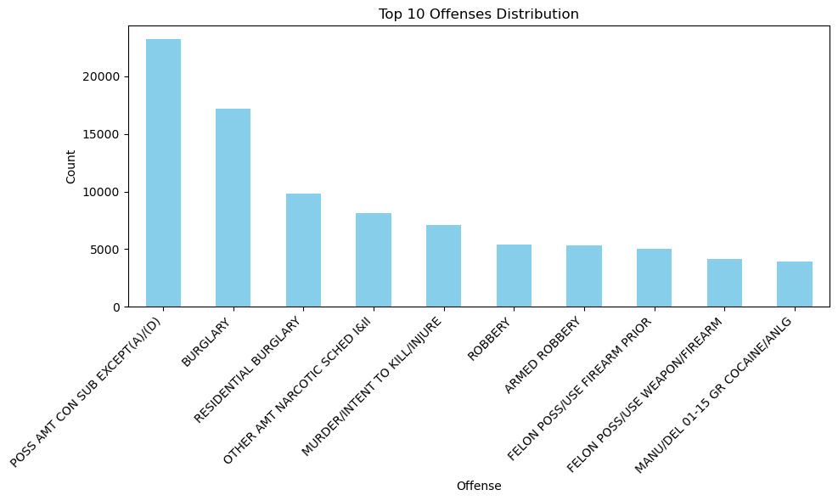

1. *Model Architecture*

4. 1. Overview:

The model architecture consists of the following major components:

1. Feature Extractor: Two separate ResNet50 backbones extract features from front and side images.

2. Fusion Layer: Outputs from both views are concatenated and processed for joint feature learning.

3. Output Layers: Separate branches for BMI regression and sex classification.

4. 2. Input Layers:

Two input layers accept preprocessed front and side facial images:

* front_input: Input shape is (224 × 224 × 3).
* side_input: Input shape is (224 × 224 × 3).

These inputs are normalized and resized to match ResNet50’s expected format.

4. 3. ResNet50 Backbone:

The pre-trained ResNet50 model is used as the feature extractor:

* Pretrained Weights: ImageNet weights are loaded to use transfer learning.
* No Fully Connected Layers: The top layers of ResNet50 are excluded (include top=False) to focus on convolutional feature extraction.
* Output Features: Feature maps are passed through a GlobalAveragePooling2D layer to produce fixed-length feature vectors.

4. 4. Dropout Layers:

Dropout regularization with a rate of 0.5 is applied after feature extraction to reduce overfitting.

4. 5. Dense Layers:

Feature vectors from both views are passed through Dense layers:

* Dense Layer for Each View: A Dense layer with 128 units and ReLU activation condenses the features into a lower-dimensional representation.
* Fusion Layer: Features from front and side views are concatenated and passed through a 256-unit Dense layer with ReLU activation.

4. 6. Output Layers:

* BMI Regression Output: A single neuron (linear activation) predicts BMI.
* Sex Classification Output: A two-neuron layer with SoftMax activation predicts the probability of each class (male/female).

The architecture diagram is as follows:

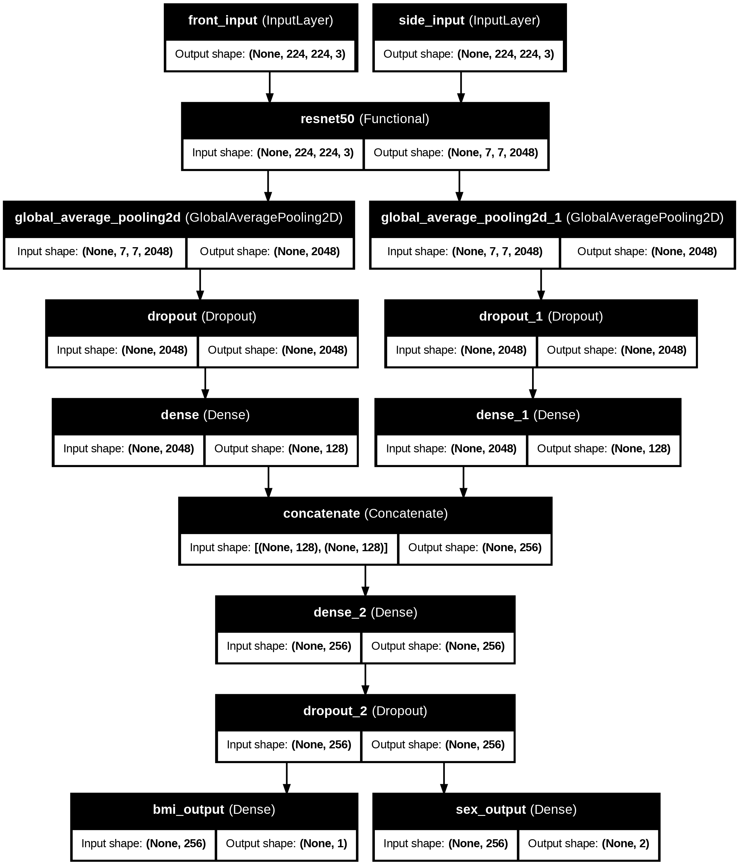

4. 7. Evaluation:

The following were used to evaluate model performance:

* BMI Prediction: Mean Absolute Error (MAE), Mean Squared Error (MSE), R-squared (R2), and Pearson Correlation Coefficient.
* Gender Classification: Accuracy.

The final metric values are as follows:

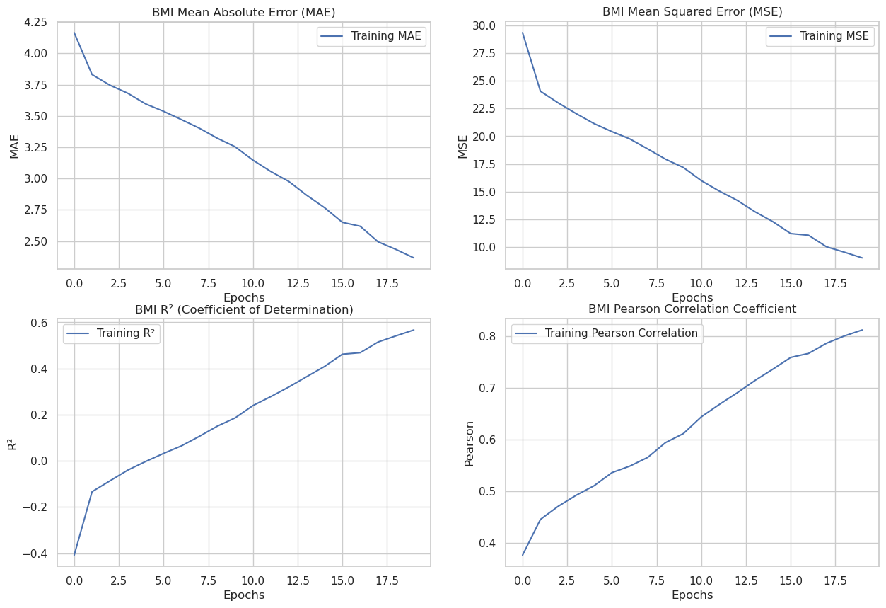

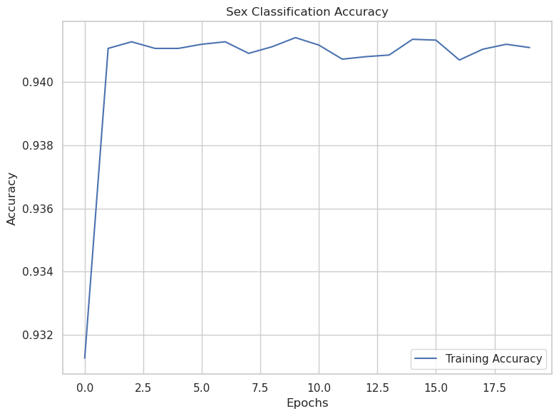

1. *Results*

5. 1. BMI Prediction:

|  |  |  |
| --- | --- | --- |
|  | Train | Test |
| MAE | 2.3651 | 3.1153 |
| MSE | 9.0137 | 16.7522 |
| R2 Score | 0.5672 | 0.2788 |
| Pearson Coefficient | 0.8115 | 0.6091 |

5. 2. Gender Classification:

* Accuracy (Train): 94.11 %
* Accuracy (Test): 93.81 %

5. 3. BMI Grading:

The BMI values were categorized as:

* Underweight: BMI < 18.5
* Normal: 18.5 ≤ BMI < 25
* Overweight: BMI ≥ 25

5. 4. Custom Image Testing:

For this part, we tested the performance of the model with the front and side-view pictures of my team members. The results are as follows:

|  |  |  |  |  |
| --- | --- | --- | --- | --- |
| Name | True BMI | Predicted BMI | True Gender | Predicted Gender |
| Thribhuvan | 23.67 | 26.21 | Male | Male |
| Lokesh | 23.83 | 22.42 | Male | Male |
| Amar Rohith | 18.68 | 23.47 | Male | Male |

1. *Conclusion*

This study demonstrates the potential of neural networks to predict BMI and classify gender using facial images. Utilizing a dataset that contains full-sized pictures of a person may yield better results, since that could help in capturing the height and weight more accurately than just having the face of a person.